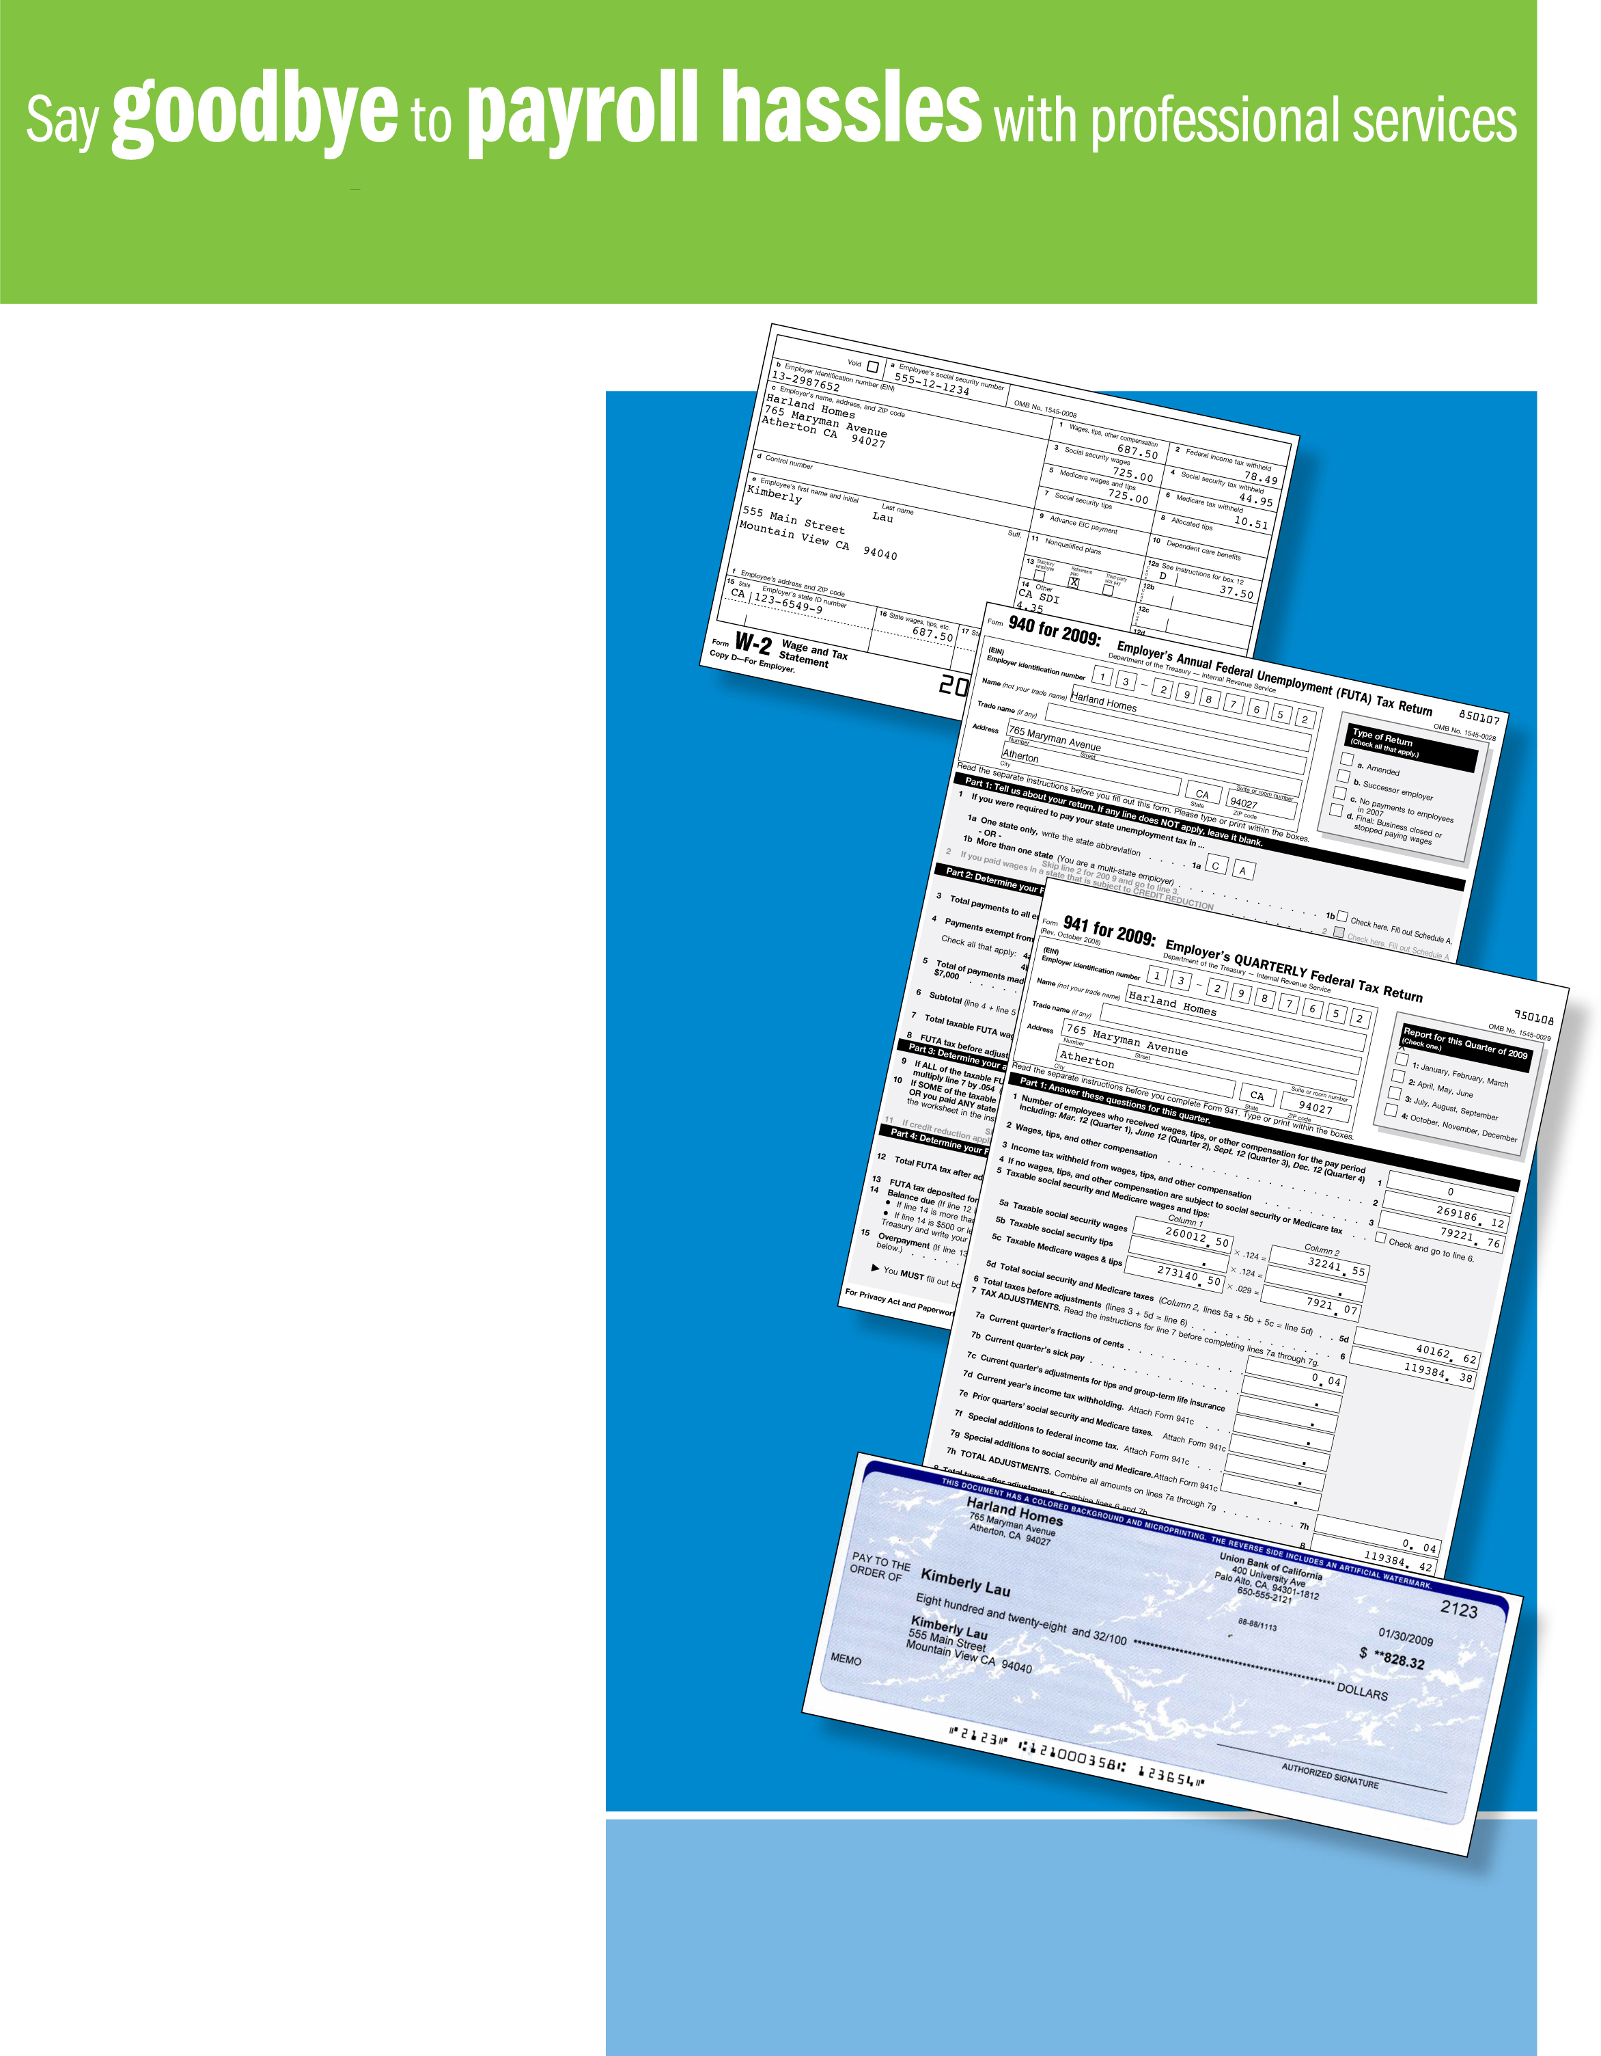
from Fagen Financial Services Inc.
Paychecks

Tax filings

Tax
payments

W-2’s
1099’s
Fagen Financial Services Inc
9231 Wicker Ave. (US 41)
St. John, IN 46373
www.fagenfinancial.com
219-365-1592
Now you can trust your payroll is in good hands. There’s nothing better than personal attention from a trusted advisor who knows your business.
No more IRS penalties!
• Did you know that each year, 1 out of 3 small businesses pays a penalty to the IRS?
• With our payroll service, you’ll never miss a tax deadline or pay the wrong amount.
Accurate payroll
you can count on
• We complete your federal and state payroll filings for you, including 941/944 quarterly forms, year-end 940 forms, and W-2’s.
• All of your payroll information will be maintained and available: employee records, past pay stubs, tax filings, and records of tax payments.
You and your employees will be pleased
• Paychecks can be electronically deposited into employee bank accounts with our Direct Deposit service. Your employees will appreciate Direct Deposit. No more trips to the bank. We also provide professional pay stubs detailing the current as well as year-to-date withholdings, vacation and sick time.
• All common pay types are supported.
• Voluntary deductions are also handled, such as insurance, retirement plans, and many others.
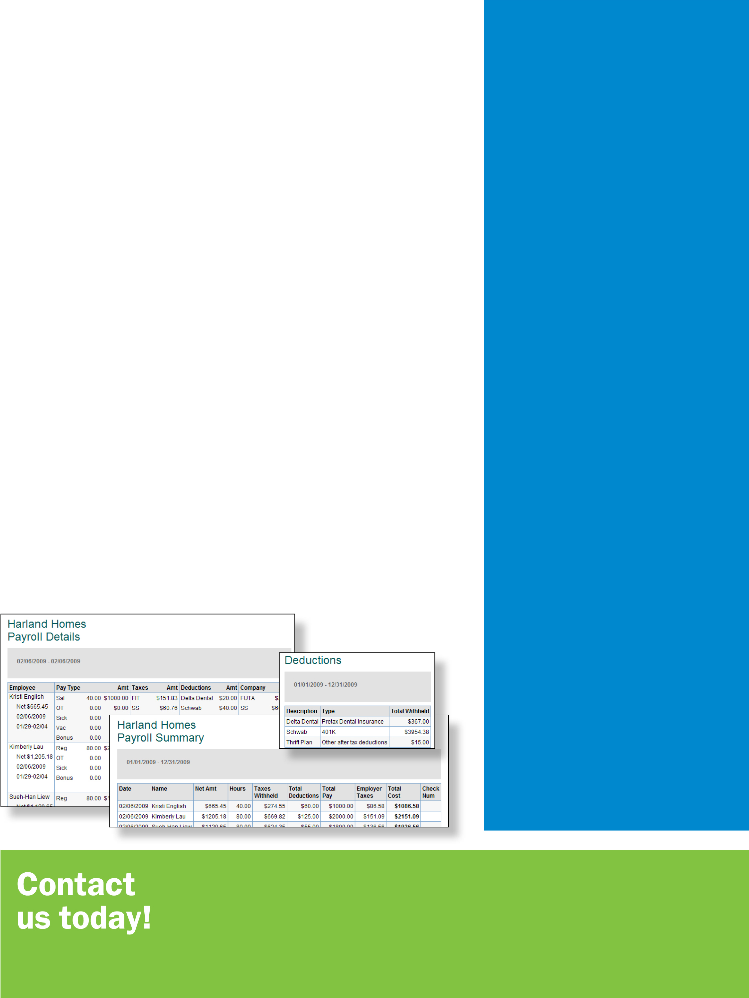

FAQs
What do I need to get started?
All we need is your company and employee information, and payroll history (if any) for this year. Call us to schedule an appointment to discuss your payroll requirements.
Can I switch payroll providers mid-year?
Yes, we can start your payroll any time as long as you have records of your payroll history.
What about W-2’s?
At year-end, we create W-2 forms for you and your employees. And we take care of filing them with the Social Security Administration.
Do employees get online access to their pay stubs?
Absolutely. Your employees can also access their pay stubs securely online at PaycheckRecords.com, 24 hours a day, 7 days a week.
Can I import payroll information to my
accounting software?
Yes, we can help you import payroll data into accounting software such as QuickBooks®, QuickBooks Online Edition, QuickBooks for Mac, Peachtree®, ATX Client Write-Up™, TaxWise Client Write-Up™, CCH ProSystem fx® Write-Up, and Microsoft® Money, so that all information is in one place.
How will I stay on top of my payroll details?
We will provide you with a variety of reports that will allow you to remain informed and in control of your payroll.

Accurate Paydays
• Guaranteed accurate federal, state and local tax calculations
• Direct deposit
• Professional paychecks and pay stubs
• Secure online employee access to pay stubs
• Payments to independent contractors
• Wage garnishments
• Vacation and sick pay tracking
• Pay types: salary, hourly wages, multiple pay rates, bonuses, cash tips, paycheck tips, expense reimbursements, allowances, holiday, and more
• Voluntary deductions: taxable and pre tax premiums for medical, dental, and vision; retirement plans; flexible spending accounts: dependent and medical care; cash advance and loan repayments; and others

Federal Tax Deposits and Filings
• Quarterly and year-end filings
• W-2’s
• W-4’s, I-9’s and employer registration forms

State Tax Deposits and Filings
• Quarterly and year-end filings
• Multi-state tax payments and filings
• New hire reporting
• Employer registration forms

Accounting Software Integration
• Payroll data integration available for QuickBooks®, QuickBooks Online Edition, QuickBooks for Mac, Peachtree®, ATX Client Write-Up™, TaxWise Client Write-Up™, CCH ProSystem fx® Write-Up, and Microsoft® Money

Detailed, Insightful Reports
• Employer reports: Tax Liability, Tax and Wage Summary, Total Pay, Tax Payments, Workers’ Compensation, Vacation and Sick Leave, Billing Summary, Total Cost, Retirement Plans
• Employee reports: Payroll Summary, Payroll Details, Deductions, Last Paycheck, Employee Details
Fagen Financial Services Inc
9231 Wicker Ave. (US 41)
St. John, IN 46373
www.fagenfinancial.com
219-365-1592

